CIMP Meeting 2015 Interest to Participate Form

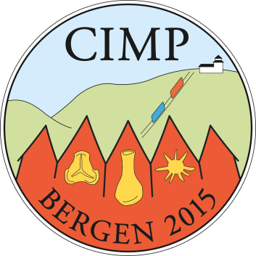
In order to determine initial interest in the Bergen, Norway, 2015 CIMP meeting, and to help us in our planning, we are requesting that you let us know about your possible participation in this meeting.

Please send an email (or answer the questions below) to Dr. Gilda Lopes (gilda.lopes@geo.uib.no), preferably before December 20th, 2014, letting her know if you think you might be attending the 2015 CIMP meeting. If you could please answer the following questions, this would greatly aid us in our initial planning.

1. Do you think you might be attending the meeting?

2. Are you interested in presenting a paper or poster?

3. Are you interested in participating in the pre-meeting field trip (Oslo area)?

4. Are you interest in participating in the post-meeting field trip (Finse)?

5. Do you think you will be attending the gala dinner on Friday, September 18, 2015?

Thank you for you interest in the Bergen, Norway, 2015 CIMP Meeting.

The Organizing Committee: Gunn Mangerud, Gilda Lopes (co-organizers), Marco Vecoli (past CIMP president), Reed Wicander (CIMP president)

